SNAPOOH MONITOR INBOX

MOBILE APP

SPECIFICATION DOCUMENT

Snapooh Monitor is an android application which can receive and share monitors of Medias belonging to street, place, POI or places.

The received monitors can be filtered using various parameters like cities, campaigns, media, tags, alerts and also by the user who clicked/shared the monitor this kind of viewing can be saved with a given name and then applied to the Inbox to narrow down to precise data.

An user can view His/her monitors and then can add tags, notes alerts to it and they can share monitors with their teams, clients etc

1. Dashboard

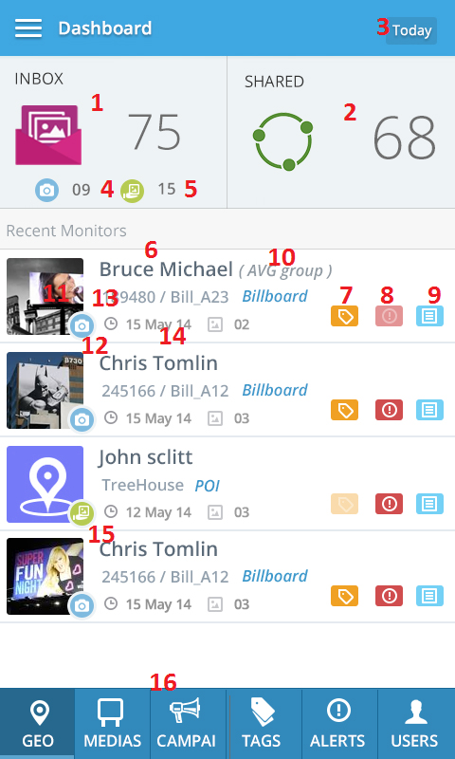

|  |  |  |
| --- | --- | --- |
| Footnote | Label | Description |
| 1 | Inbox | This is the number of monitor that the user has received during the time period selected in footnote #3.  Clicking on this will open up the inbox. Ref 2.0 |
| 2 | Shared | This shows the number of monitors that the user has shared. Clicking on this will open the ************** TBD |
| 3 | Date Picker | This can be used to select the date range. Ref.2.4 |
| 4 | Captured | This shows the number of monitors captured. (captured from Snapooh Monitor from users linked by the media owner) |
| 5 | Shared | This number shows the monitors that are shared by someone. – Other Snapooh monitor view users. |
| 6 | Recent monitors | This list shows the most recent monitors(shared/received) This list is not affected by the date selector  The name of the user who has shared/clicked the image is shown here.  *NOTE- clicking on any of these notification will take the user to the inbox detail page----- REF 2.6 |
| 7 | Tags | If the monitors has tags, this icon is highlighted, otherwise this icon is faded out. Ref 3rd monitor icon |
| 8 | Alerts | This indicates if the monitor has alerts or not. |
| 9 | Notes | This indicated if the monitor has notes or not. |
| 10 | Company name | If the user belongs to a company, the company name is displayed here. |
| 11 | Thumbnail | The brief thumbnail of the monitor is shown here |
| 12 | Clicked icon | If the monitor is received by the user who has clicked, then this will have a camera icon |
| 13 | ID | The media ID , alias and the media type is shown here. |
| 14 | Date | The date on which the monitor was received |
| 15 | Shared icon | If the monitor is shared by someone, then this icon appears. |
| 16 | Views | This bar will be present on the dashboard, upon clicking anywhere on the view bar, the view is shown, the view window slids up. REF |

1. Inbox(from dash)

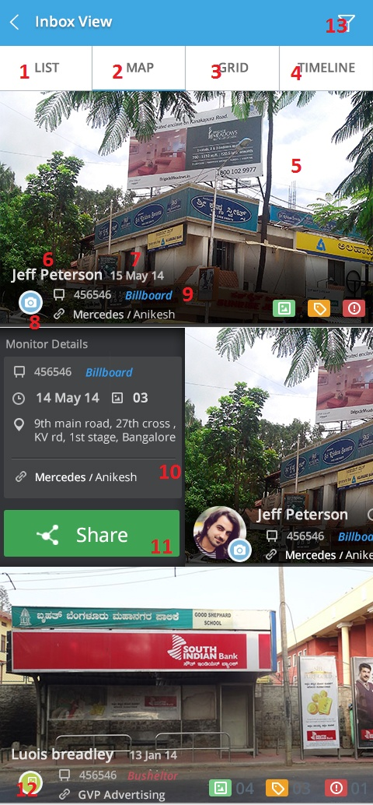

|  |  |  |
| --- | --- | --- |
| Footnote | Label | Description |
| 1 | List | This is the default view when the user comes from the dashboard, other views can be switched by sliding right or by tapping on the tabs above. |
| 2 | Map | Map view shows the map of the monitors, map reflects all the monitor present Ref 2.1 |
| 3 | Grid | This tab shows the grid view of the monitor- grid Ref 2.2 |
| 4 | Timeline | This shows the timeline view of the entire media. |
| 5 | Monitor | The monitor first monitor image is shown here, on click of this, the detailed view is shown Ref….2.6 |
| 6 | User name | The name of the user clicked/shared is shown here. |
| 7 | Date | The received date of the monitor. |
| 8 | Captured | If the monitor is received by the user who has clicked, then this will have a camera icon. |
| 9 | Media type | The media type is shown in here. |
| 10 | Slide options | When a monitor is slid to the right, the slide out option appears along with media ID, type, received date, number of images, address and link. |
| 11 | Share | An individual monitor can be shared using this button. Ref**2.2 |
| 12 | Shared icon | If the monitor is shared by someone then this icon appears. |
| 13 | Filters | Filters can be used to filter the monitors that are received. Ref***** |

* 1. Map view

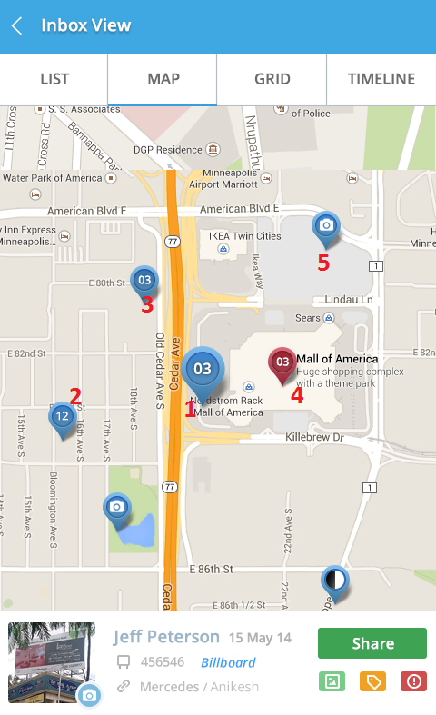

The monitors are indicated on the map by different markers, red marker will always indicate a place media. If one location has more than one media, then the marker will show the number of medias in that location.

|  |  |  |
| --- | --- | --- |
| Footnote | Label | Description |
| 1 | Marker(highlighted) | The highlighted marker, upon tapping on one marker, the marker is highlighted and the information of that monitor is shown below. Ref 2.1.1 |
| 2 | Map | Map view shows the map of the monitors, map reflects all the monitor present Ref 2.1. |
| 3 | Grid | This tab shows the grid view of the monitor- grid Ref 2.2 |
| 4 | Place | Clicking on a place will zoom in to a place with floor view(if available) Ref 2.1.2 |
| 5 | Unlinked | If a media has been shared without linking, then the location of the monitor is shown with a camera icon. |

|  |  |  |
| --- | --- | --- |
| 1 | Share | An individual monitor can be shared using this button.  A slide over is shown over the screen,     1. The list of previously shared email id is shown. REF******** 2. Email ids can be entered separated by commas 3. Share will share the selected monitor. |
| 2 | Info | Info such as name, media id, type, and linked info is shown. |
| 3 | Marker | The map marker indicated a monitored media. The number on the marker indicates that the number of monitors that has been received for that monitor.  The big marker is shown when the marker is clicked and the info of the monitor is shown. |
|  |  |  |

* + 1. Map View(multiple media monitors)

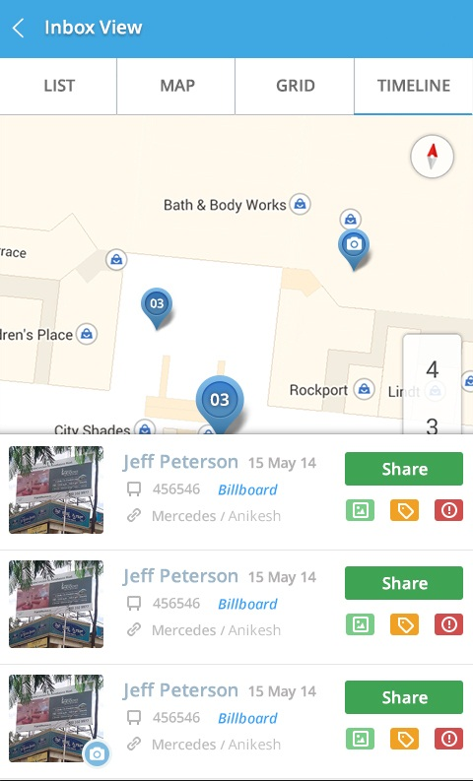

If a location has more than one media, and upon clicking on the marker, media info is shown in list. The container will stop at 3 in one view, more medias can be seen upon scrolling. The map is moved up to accommodate the list.

* + 1. Place monitor.

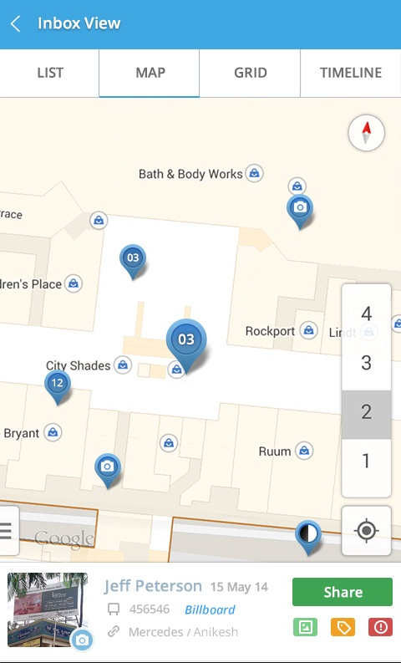

If available, the place will have floor selection and monitor will be indicated by the map marker if the monitor has happened.

* 1. Grid view

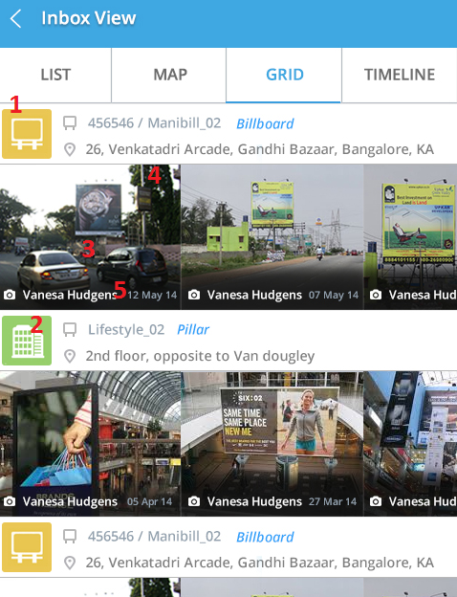

|  |  |  |
| --- | --- | --- |
| Footnote | Label | Description |
| 1 | Icon | This icon appears when the monitor belongs to street,. |
| 2 | Place icon | The place icon indicates that the monitor belongs to place. |
| 3 | Monitors | This shows the monitor received for the following media.  ONCLICK- the respective monitor is shown as a pop up. Upon clicking on the pop up, the respective monitor detail page is shown. |
| 4 | Count | The number of images in the monitor is shown here. |
| 5 | Label | The name of the person who shared it or clicked it ishown here along with the date. |
|  |  |  |

Scenerio- if there is only one monitor, the monitor will be shown on the left most side of the screen and the space on the right side will remain white.

Scrolling is possible only if there are more than 3 monitors to show.

The other monitors can be scrolled left or right.

* 1. Timeline view.

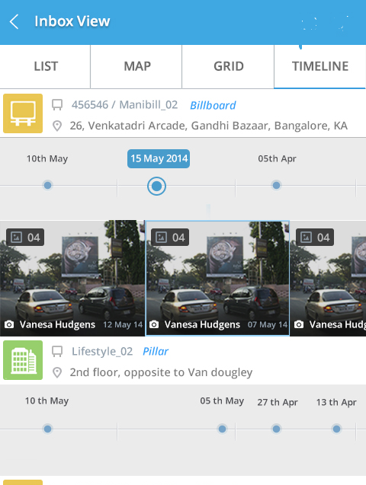

Time line view shows the monitors that have happened, the data visible here is shown based on the time range that the user has selected either on dashboard or views.

* 1. Date Picker

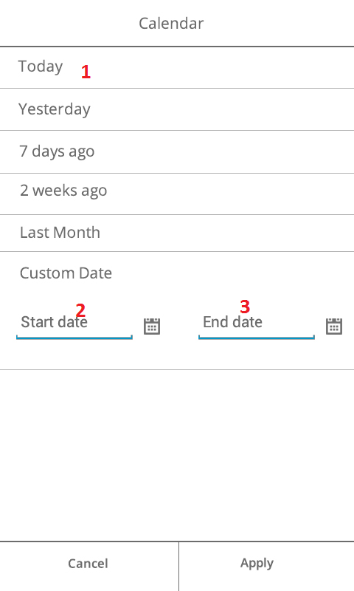

This date range will effect the data on the dashboard, the inbox and all the views of the inbox including list, map, grid and timeline view.

|  |  |  |
| --- | --- | --- |
| Footnote | Label | Description |
| 1 | Options | These options when selected will reflect the data showing on the dashboard. |
| 2 | Custom date | Custom date can be selected to based on the requirement.  Start date and end date should be specified. |
| 3 | End date |  |

Scenerio- If monitors are not available during the selected duration tab or custom date, prompt the user with an alert box(while within the calander activity) “No monitors found during the selected date range.” Pick another duration.

* 1. Monitor detail (onclick)

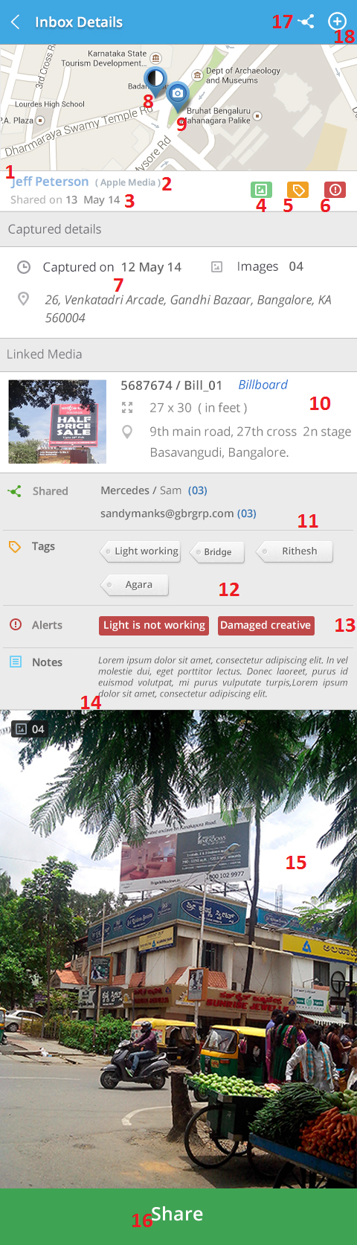

|  |  |  |
| --- | --- | --- |
| Footnote | Label | Description |
| 1 | Name | The name of the person who has captured or clicked the monitor is shown here |
| 2 | Company | , if the person belongs to a company, then the name of the associated company is shown in brackets |
| 3 | Date | This shows the date of the sharing/clicking of the monitor. If the monitor is clicked then “Clicked on “ is shown, if the monitor is shared, then “Shared on” is shown followed by the date. |
| 4, 5 & 6 | Indicators | These icons are in a highlighted state respectively if the monitor consists, |
| 7 | Captured details | This shows the details of the capture such as the date, the number of images captured, and the captured location. (not media’s location) |
| 8 | Map marker | This marker shows the location of the media. |
| 9 | Captured location | This marker shows the location of the monitor- The location where the media was monitored(captured) |
| 10 | Linked | This shows the details of the linked media, this contains media image, media location, ID and alias, media type, and size of the media. |
| 11 | Shared | If the monitor has been shared, then the sharing history is shown here, the info in the bracket denotes the number of images that have been shared to the email ID. |
| 12 | Tags | The tags which are sent along with the media, or the tags which are added using (ref call out action # 18) are shown here. |
| 13 | Alerts | The tags which are sent along with the alerts, or the alerts which are added using (ref call out action # 18) are shown here. |
| 14 | Notes | The notes which are sent along with the notes, or the notes which are added using (ref call out action # 18) are shown here. |
| 15 | Images | The images that have been captured. More images can be viewed by swiping to the left or right.  The number of images. That are present are shown on the top left corner. |
| 16 | Share | The monitor can be shared using this share button. . ref 2.7 |
| 17 | Share | The monitor can be shared using this share button. . ref 2.7 |
| 18 | Add | This button can be used to add tags, alerts or notes. |

**Scenario:** If the media is not linked, then the media location (pointer) on the map is not shown. The Linked media tab callout #10 is not shown-ref image.

* 1. Sharing activity

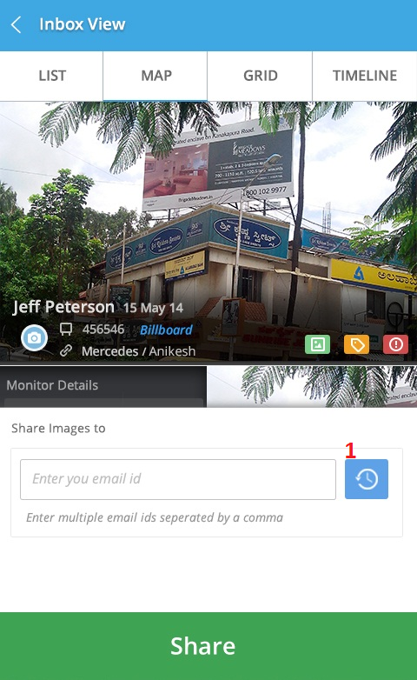

A monitor can be shared to email Ids, this sharing activity can be accessed from within the monitor details or in the monitor list view by sliding a monitor right or long pressing on a monitor.

|  |  |  |
| --- | --- | --- |
| Footnote | Label | Description |
| 1 | History | The recently shared(history) button shows the list of recently shared emails – Limit to last 10 Ref 2.7.1. |

* + 1. Shared History.

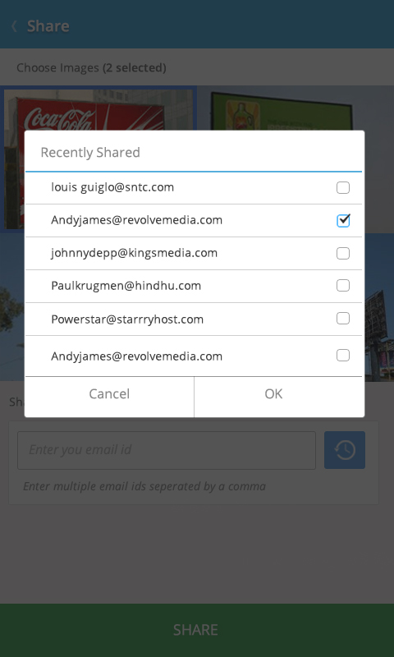

The user can multiselect from the list of the recently shared emails. Upon selecting and clicking on ok, the emails Ids are entered in the text box automatically separated by commas.

Scenerio: If there are no recently shared emails, an alert box is shown with the text “No recently shared email available” “OK”

The list dynamically shrinks if there are lesser elements, the max limit of this list is 10.  
  
  
  
  
  
  
Description:

Snapooh View is an Andriod app which facilitates receiving and sharing media monitors on the go. A user friendly and best experience app developed for Snapooh vendors to view all information about the monitors in their account inbox.

* Beta version

Features:

* Instant notification alert on receiving new monitors
* A single dashboard view displaying important parameters of the monitors
* Detailed view of each monitor with geo tags, photos, maps and alerts
* Use calendar list to filter your view of media monitor’s.
* Share monitors with your team and clients
* Get monitoring data on your smartphone 24/7

Requirements:

* OS
* Data connection

Coming Next:

* Mashup view of monitors